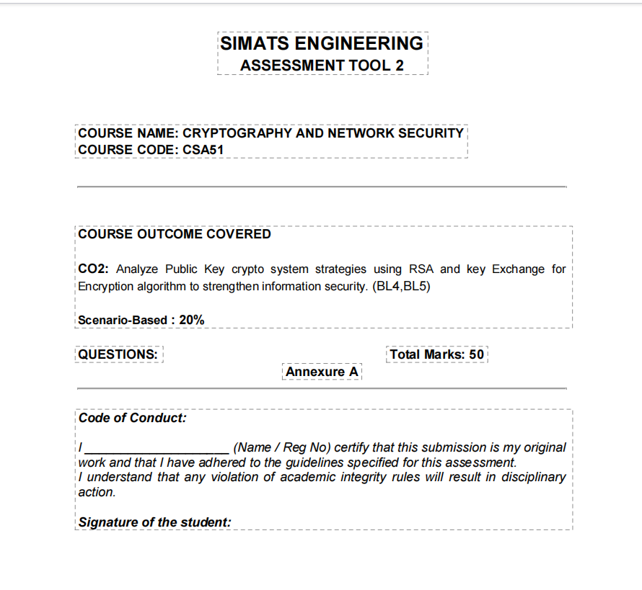

Question 1: Secure Data Transmission using Block Cipher
Scenario: A company is transmitting repeated financial data blocks over a network. Initially, they used Electronic Codebook (ECB) mode and noticed identifiable patterns in the ciphertext.
Part A: Explain why this issue occurs.
The vulnerability observed in Electronic Codebook (ECB) mode arises directly from its underlying deterministic design. In ECB mode, the plaintext message is divided into fixed-size blocks (e.g., 64 bits or 128 bits), and each block is encrypted independently using the exact same secret key (K).
Key technical reasons for the occurrence of ciphertext patterns include:
- Deterministic Mapping: Mathematical formula C_i = E_K(P_i) ensures that identical plaintext blocks (P_i) always produce identical ciphertext blocks (C_i). Financial transactions frequently contain repetitive structure—such as standard XML/JSON headers, padding, recurring account fields, or zero-filled pads.
- Lack of Diffusion across Blocks: ECB lacks block chaining or inter-dependency. Encryption of block 'i' is totally isolated from block 'i-1' or 'i+1'.
- Pattern Preservation & Eavesdropping Risks: An active or passive network eavesdropper (padders/sniffers) can discern structural boundaries, data repetitions, and transaction frequency without needing to decrypt the key (famous visualized by the ECB Penguin phenomenon).
Part B: Suggest a more secure block cipher mode and justify your choice based on the scenario.
Recommended Mode: Cipher Block Chaining (CBC) Mode (or Galois/Counter Mode - GCM for authenticated encryption).
Justification based on Financial Transmission Scenario:
- XOR Mechanism with Initialization Vector (IV): Before encryption, each plaintext block P_i is XORed with the previous ciphertext block C_{i-1}. For the first block, a random and unique Initialization Vector (IV) is used: C_1 = E_K(P_1 ⊕ IV) and C_i = E_K(P_i ⊕ C_{i-1}).
- Pattern Elimination: Even if financial data contains identical blocks (e.g., repeating payment amounts or standard headers), the XOR step with differing prior ciphertexts ensures that every resultant ciphertext block is entirely distinct and randomized.
- Semantic Security: CBC ensures semantic security; an attacker cannot gather any statistical relationship between identical plaintexts across separate financial transmissions.
Question 2: Choosing an Encryption Algorithm for Banking System
Scenario: A banking application needs high security and moderate performance for encrypting customer transactions. The available options are DES, 3-DES, and Blowfish.
Part A: Identify the most suitable algorithm for this scenario.
Most Suitable Algorithm: Blowfish (or modern AES as an industry standard, but among the three options given, Blowfish is the clear superior choice).
Part B: Justify your choice based on security strength and efficiency.
Comparative Analysis of Options:
Algorithm | Key Length | Security Assessment | Performance / Efficiency
DES | 56 bits | Completely Broken / Insecure (Vulnerable to brute-force within hours) | Fast, but obsolete
3-DES (TDEA) | 112 / 168 bits | Medium Security (Vulnerable to Meet-in-the-Middle & Sweet32 attacks; Deprecated by NIST) | Very Slow (3x execution overhead due to triple encryption loops)
Blowfish | 32 to 448 bits (Variable) | High Security (No effective cryptanalytic attacks known to date on full rounds) | Exceptional Speed & Memory Efficiency (Optimized for 32-bit CPUs)

Detailed Justification:
- Security Strength: DES's 56-bit key is inadequate against modern computation. 3-DES is vulnerable to Sweet32 (collision attacks on 64-bit block sizes) and is officially deprecated by NIST. Blowfish offers variable key lengths up to 448 bits, providing massive resistance against brute-force attacks.
- Computational Efficiency: Blowfish utilizes a 16-round Feistel cipher with key-dependent S-boxes, designed to run extremely fast on 32-bit processors. 3-DES requires 48 pipeline operations per block (Encrypt-Decrypt-Encrypt), making it computationally sluggish for high-volume banking transactions.
Question 3: Key Exchange in an Unsecured Network
Scenario: Two users (Alice and Bob) want to establish a secure communication channel over a public network using Diffie-Hellman key exchange. However, the network is vulnerable to active attacks.
Part A: Explain how the key exchange works in this scenario.
The Diffie-Hellman (DH) protocol allows two parties to establish a shared secret key over an unsecure medium without transmitting the key itself. It relies on the computational hardness of the Discrete Logarithm Problem (DLP).
- Step 1: Public Parameter Agreement: Alice and Bob publicly agree on a large prime number p and a primitive root modulo p, generator g.
- Step 2: Private & Public Key Generation: Alice selects private key a (where a < p) and computes public key A = g^a mod p. Bob selects private key b (where b < p) and computes public key B = g^b mod p.
- Step 3: Exchange of Public Values: Alice sends A to Bob over the unsecured network; Bob sends B to Alice.
- Step 4: Shared Secret Calculation: Alice computes Shared Key K = B^a mod p = (g^b)^a mod p. Bob computes Shared Key K = A^b mod p = (g^a)^b mod p. Since (g^b)^a ≡ (g^a)^b mod p, both parties share the identical secret key K.
Part B: Identify a possible security threat and suggest a solution to mitigate it.
Primary Security Threat: Man-in-the-Middle (MitM) Attack.
Threat Mechanism: Standard Diffie-Hellman lacks authentication. An active adversary (Darth/Eve) positioned on the network can intercept Alice's public key A and substitute it with their own key A_Darth, sending it to Bob. Similarly, Darth intercepts Bob's public key B and sends B_Darth to Alice. Darth establishes separate shared keys with Alice and Bob, allowing Darth to decrypt, read, modify, and re-encrypt all passing traffic undetected.
Mitigation Solutions:
- 1. Digital Certificates & PKI (Station-to-Station Protocol - STS): Alice and Bob digitally sign their exchanged public parameters (A and B) using their RSA or ECDSA private keys verified via Digital Certificates issued by a trusted Certificate Authority (CA).
- 2. Pre-Shared Key (PSK) Authentication: Incorporate an authenticated hash function (HMAC) using a pre-shared secret to authenticate public key transmissions.
Question 4: Public Key Cryptography for Email Security
Scenario: An organization plans to implement RSA for secure email communication across its enterprise enterprise infrastructure.
Part A: Describe how RSA can be used for encryption and decryption in this scenario.
RSA is an asymmetric algorithm based on the prime factorization problem of large integers. In an email environment (e.g., PGP / S/MIME):
- Key Pair Generation: Each employee generates a key pair: Public Key KU = {e, n} (published in company directory) and Private Key KR = {d, n} (kept strictly confidential).
- Confidential Email Encryption Flow: To send a confidential email to Bob, Alice retrieves Bob's Public Key (KU_Bob). She computes Ciphertext C = M^e mod n. Only Bob's Private Key (KR_Bob) can compute Decrypted Message M = C^d mod n.
- Hybrid Cryptography System (Practical Email Architecture): Because RSA is computationally expensive for large email attachments, hybrid encryption is used: Alice generates a random symmetric session key (K_session), encrypts the email content using AES-GCM with K_session, and then encrypts K_session using Bob's RSA public key.
- Digital Signatures for Non-Repudiation: Alice encrypts the hash of her email using her own Private Key (KR_Alice). Bob decrypts the signature using Alice's Public Key (KU_Alice) to verify sender identity and message integrity.
Part B: Explain how key distribution and management play a role in maintaining security.
Key distribution and lifecycle management are critical to prevent key spoofing and unauthorized access:
- Public Key Infrastructure (PKI) & CAs: Deploying Digital Certificates (X.509 standard) ensures public keys are digitally signed by a trusted internal CA, binding employee identities to their respective public keys and preventing spoofing.
- Certificate Revocation Lists (CRL) & OCSP: If an employee loses their key or leaves the organization, their certificate must be revoked immediately via CRL or Online Certificate Status Protocol (OCSP).
- Secure Private Key Storage: Private keys must be protected on hardware security modules (HSM), TPM chips, or password-protected encrypted key stores.
Question 5: Cryptography for IoT Devices
Scenario: A smart home system uses low-power IoT devices that need secure communication. The designer must choose between RSA and Elliptic Curve Cryptography (ECC).
Part A: Analyze the constraints of IoT devices.
Smart home and IoT environments present stringent operational constraints:
- Processing Power & Microcontrollers: IoT microcontrollers (e.g., ARM Cortex-M, ESP32, 8-bit AVR) operate at low clock speeds (MHz vs GHz) and lack dedicated math coprocessors.
- Memory Limitations: Extremely small RAM (few KB) and ROM/Flash storage, making large cryptographic keys and complex code libraries problematic.
- Energy & Battery Constraints: Devices are often battery-powered; intensive mathematical calculations drain energy rapidly, reducing device lifespan.
- Bandwidth Restrictions: Low-power wireless protocols (Zigbee, BLE, LoRaWAN) have small packet payload sizes; transmitting massive keys adds severe network overhead.
Part B: Recommend a suitable cryptographic approach and justify your answer.
Recommendation: Elliptic Curve Cryptography (ECC).
Justification and RSA vs ECC Comparison:
Security Level (Bits) | RSA Key Size | ECC Key Size | Key Size Ratio / Savings
80-bit (Legacy) | 1024 bits | 160 bits | 1 : 6 reduction
128-bit (Standard) | 3072 bits | 256 bits | 1 : 12 reduction
256-bit (High) | 15360 bits | 512 bits | 1 : 30 reduction

- Equal Security with Much Smaller Keys: A 256-bit ECC key yields security equivalent to a 3072-bit RSA key. Smaller key sizes drastically reduce storage and packet overhead.
- Reduced Computational & Power Overhead: ECC scalar multiplication requires significantly fewer CPU cycles than RSA modular exponentiation, consuming up to 90% less battery energy.
- Lower Bandwidth Consumption: Smaller signature and key sizes transmit faster over low-bandwidth IoT networks (Zigbee/BLE), reducing network collisions and latency.
Evaluation Rubrics Reference
Criteria | Weight (%) | Level 4 (Exemplary) | Level 3 (Proficient) | Level 2 (Developing) | Level 1 (Beginning)
Understanding of Scenario | 20% | Demonstrates clear & complete understanding | Good understanding with minor gaps | Partial understanding; misses key aspects | Misinterprets/fails scenario
Identification of Key Issues | 20% | Accurately identifies all relevant issues | Identifies most key issues | Identifies limited issues | Unable to identify key issues
Application of Concepts | 25% | Applies concepts effectively to scenario | Applies concepts with minor errors | Limited/partially correct application | Unable to apply concepts
Decision Making | 20% | Well-reasoned, logical decisions with strong rationale | Logical decisions with some rationale | Weak decisions with limited justification | No clear decisions made
Clarity of Response | 15% | Clear, structured, logically presented | Generally clear with minor issues | Somewhat unclear or poorly structured | Disorganized & difficult to read

